Queen Own Cameron Highlander of Canada

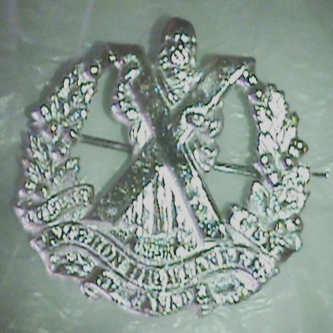

Current Hat badge Metal Silver finish

Price: $12.00 each

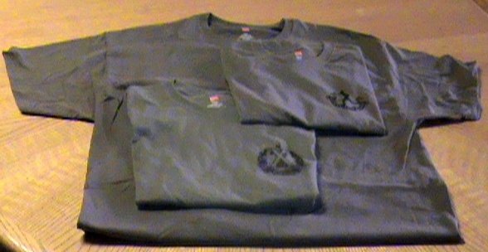

T Shirt Army Green

Queens Own Highlander of Canada T Shirt with

serving badge imprinted on the left top.

Price: $12.00

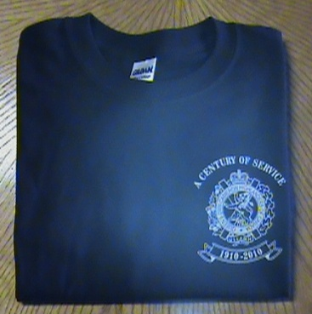

T Shirt Dark blue

Queens Own Highlander of Canada 100th anniversary T Shirt with 79th badge,

“A century of service” and Years 1910 2010 imprinted on the left top.

Price: 15.00 each

Hoody Dark Blue

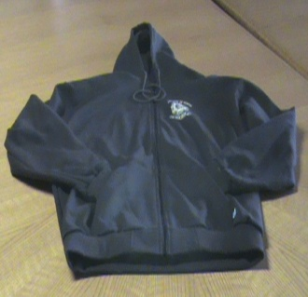

Queens Own Highlander of Canada 100th anniversary Hoody with 79th badge,

“A century of service” and Years 1910 2010 imprinted on the left top.

Price: $45.00 each

PT Shorts

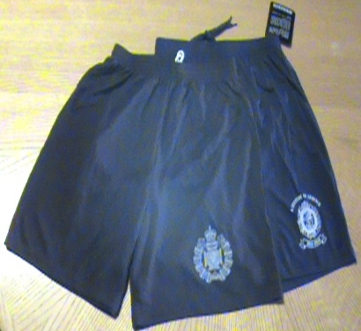

Queens Own Highlander of Canada 100th anniversary Dark blue with 79th badge,

“A century of service” and Years 1910 2010 imprinted on the left thigh.

Price: $25.00 each

Baseball caps

Queens Own Highlander of Canada’s

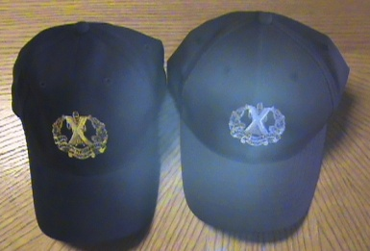

1. Dark blue cap with gold current serving badge embroidered crest
2. Black cap with white current serving badge embroidered crest.

Price: $15.00 each

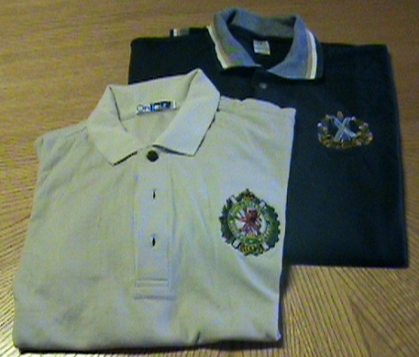

Golf Shirts

Queens Own Highlander of Canada’s

1. Dark blue shirt with full colour current serving badge embroidered crest.
2. Ivory shirt with full colour 79th serving badge embroidered crest.

Price: $40.00 each

Wine Flask

Royal Winnipeg Rifles black etched running devil (current colour dogs).

Queens Own Highlander of Canada’s black etched current serving badge.

Price: 30.00 each

Wrist Watches

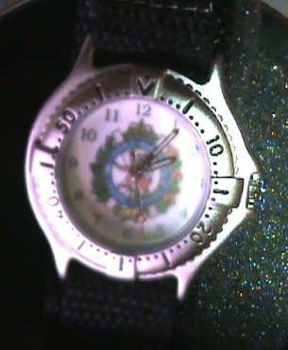

Sturdy watches with night lummination.

Queens Own Cameron Highland of Canada watch with full colour 79th badge imprinted in the middle.

Price: $45.00 each

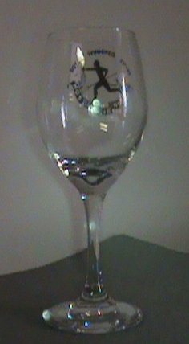

Wine Glass

Royal Winnipeg Rifles watch with dark gray running devil (current colour dogs) imprinted in the middle.

Price: 5.00 each

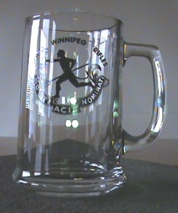

Beer Mug

Royal Winnipeg Rifles watch with dark gray running devil (current colour dogs) imprinted in the middle.

Price: 10.00 each

